Deep Learning for Flow Scheduling in Cloud Datacenters

Mair Muteeb Javaid
LUMS
17030025
@lums.edu.pk

Masooma Nazir
LUMS
17030018
@lums.edu.pk

ABSTRACT
The traffic originating from cloud data center racks usually follow a heavy-tailed distribution. Flow scheduling schemes as well as AQM policies such as DCTCP, L²DCT, pFabric and Codel, RED, have been proposed which cater to heavy tailed distributions of network traffic and provide minimum flow completion times for short/long flows. Facebook released a dataset which describes light tailed workload characteristics inside it’s cloud data center. There are currently no effective flow scheduling schemes which provide low AFCTs(Average Flow Completion Times) as network traffic switches between heavy to light tailed distributions and vice versa. We carried out measurements by leveraging computer-generated transport protocols, RemyCCs, to determine how well they fare against datacenter workloads and topology.
Keywords
Congestion Control, Workloads, Heavy-tailed, Light-tailed, remy offline, RemyCC

INTRODUCTION

Cloud based Data centers such as Google, Microsoft and Amazon are geographically distributed, often containing more than 10K servers. On a smaller scale, datacenters are also utilized in private enterprises and internationally known universities where the servers scale out to a few hundred to thousands of them. Cloud datacenters host cloud-based services such as web searches, web servers, storage, online gaming, compute machines and Instant Messaging. The network traffic in data centers is small in size i.e. less than 10KB lasting a few hundred milliseconds, with under 10K flows per rack for every second. It is interesting to note that around 80% of the traffic originated at servers remains within the racks for large cloud datacenters. In the past, researchers have tried to solve the problem of congestion control using end-to-end schemes accompanied by flow scheduling policies and queue-management mechanisms which have resulted in a plethora of transport protocols providing solutions for problems such as Incast, short and long flows’ minimum flow completion times, buffer-bloat etc. In the past few years, evolving link technologies has led to higher link speeds and lower delays with increasing bandwidth-delay products. Datacenters experience short flows which are sensitive to latency and follow some deadlines and large flows which require greater bandwidth and can easily clog up the queues for short flows due to their increased volume of data. Short flows have sizes of around less than 1MB and usually around a few KBs. Facebook released in 2015, a paper which explained how it’s workload distribution consisted of light-tailed distributions as opposed to heavy-tailed around which most of the previous congestion control protocols, such as DCTCP, pFabric, PASE etc., were built to optimize for. Our approach was to leverage Remy algorithm which is based upon an optimization function and millions of simulations running in an offline stage which produces an optimal protocol with maximum throughput and minimum delay in accordance with the breadth of network configurations provided to it.

RELATED WORK

Permission to make digital or hard copies of all or part of this work for personal or classroom use is granted without fee provided that copies are not made or distributed for profit or commercial advantage and that copies bear this notice and the full citation on the first page. To copy otherwise, or republish, to post on servers or to redistribute to lists, requires prior specific permission and/or a fee.
Conference’04, Month 1–2, 2004, City, State, Country.
Copyright 2004 ACM 1-58113-000-0/00/0004…$5.00.

pFabric ensures minimum average flow completion times for short and long flows by separating the rate control from flow scheduling inside data center networks. Their dataset consists of heavy-tailed workloads i.e. web search and data mining based on real production data centers where 3.6% of the flows account for 95% of the workload for data mining tasks and in case of web search, 30% of the flows are responsible for 95% of the data. pFabric leverages the in-network prioritization and associates each packet with priority numbers to perform flow scheduling using knowledge about the flow sizes. The scheduling algorithm allows them to avoid the issue of queue buildups and packet droppings as the higher priority traffic is serviced first and does not get affected by such issues [1]. DCTCP addresses the issues of Incast, queue buildups and buffer pressure, which take place as a result of greedy long flows which take up the buffer space and as a result, does not allow TCP to absorb large sets of incoming packets or obstruct flows passing through another port in the switch. DCTCP improve the performance in data centers by using the ECN notification in the network to notify the end user about congestion.L²DCT is a similar protocol which favors short flows through it’s foundational mechanism and only provide the fair throughput to long flows once short flows have exited the network. TCP Ex_Machina altogether drop the idea of using end-host schemes such as window adjustment according to an α value or modifying the switch/router to prioritize flows. Instead it asks the question of what each sender requires of it’s network connection and in most cases the answer is high throughput and low delay, irrespective of whether the workload distribution is light-tailed or heavy-tailed. It then maximizes the objective function according to the prior assumptions made about the network and generates a flow table where each entry is a rule instructing the sender which action to perform when a sender experiences some particular network conditions. This flow table is called RemyCC. For each ACK received, the sender queries a lookup table pre-computed by the system, by running offline beforehand, which informs it about the action to be performed.. The actions are related to how much data should be sent and the parameters for varying the size of the congestion window. RemyCC provided a better median throughput and lower queueing delay when compared with excellent general-purpose congestion control mechanisms. It also outperformed all human generated congestion algorithms on networks which obeyed the rules according to prior knowledge provided to the RemyCC in its offline design phase.Our approach is to implement Remy on the data center environment with fat tree topology in order to optimize for datacenter workload distributions which fluctuate between heavy and light tailed workloads. We also compare it with the congestion control techniques that requires in- network changes like XCP and sfqCoDel.

DESIGN AND EVALUATION
Networks do not provide complete information about it’s conditions such as the packet losses at switches, queueing delays, network capacity or the current or future load of a node in the network. In the wild, networks are unpredictable and are probed for metrics such as link capacity or congestion taking place at queues using for example ECN marks which assist endpoints in adjusting to those network conditions. Remy models it’s congestion control schemes as Markovian where a future state, where a state corresponds to a network condition and parameters, only depend on the current state and a sender abstains or sends packets everytime assessing the situation of the network infrastructure. The offline stage in Remy populates a flow table determining the three tuple action<cwnd increment, cwnd multiple, sender_rate> to be taken as a result of the network parameters which are; exponentially weighted moving average of acks received, exponentially weighted moving average of timestamps reflected in acks and ratio of minimum RTT : the recent RTT observed. It takes as input network configurations with the min/max value and how much to increment it to generate multiple such configurations. The most used rule is improved upon incrementing the action values where the increments are increasing geometrically as new values gets further from the original value. If the new action performs better than the most used rule in that epoch, it is substituted in place of the latter. After this, the most used rule is divided among the three axes of the input configuration, or memory as it is called in [3] into 8 new rules with the same action as before. The computer generated algorithm creates a transport protocol at the end of this offline stage called RemyCC which is used in online stage to test it on datacenter environments.
In the offline stage implemented as a c++ project with protobuf library to serialize the outputted flow table to be used in the online stage, the topology has been emulated as a simple dumbbell one where a group of senders create flows using a period of on and off times. These intervals are modeled using exponential distribution where the lambda is the inverse of mean_on or mean_off time. The delays are included in terms of propagation and queuing delay where the intermediate router uses a DropTail policy.
Once a simulation has been performed on the given topology, a score is outputted for each sender :
U=log(throughput) – δlog(delay)
This prioritizes delay according to the δ value and in turn, specifies the importance of throughput against delay.

We first carried out measurements to observe how a newly generated RemyCC, using a simple dumbbell topology performs against TCP NewReno, Cubic, Vegas, linux compound in order to validate results in the paper.

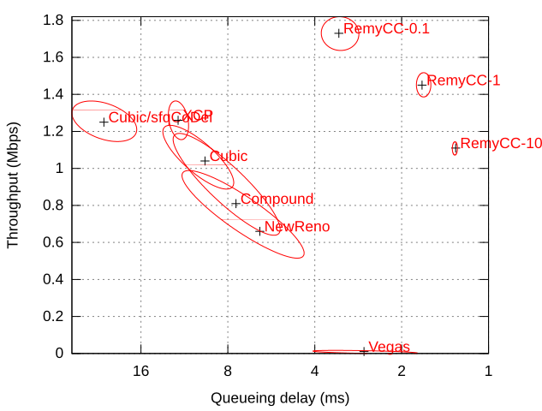
Figure 1

As it can be seen, RemyCC performs fairly well against the other protocols and outperforms most of them in terms of average FCT and throughput. Therefore we decided to test Remy by modifying the offline code by changing it’s topology to one slightly more similar to datacenters where we added a layer of TOR switches in between the senders and receiver and emulated the workloads using a CDF given in the paper[5] by changing the mean on-off times of senders which can generate the short and long flows needed for a datacenter workload. We tested the generated RemyCC by importing it into the ns-2 project which contains the online phase code of Remy. The initial dumbbell topology provided in this online phase was modified to a fat-tree topology with eight end-hosts and a spine consisting of two cores. The datacenter workload that we used was of web searches distribution present commonly present in datacenters and was taken from the github project PIAS-NS in the form of CDF text files. Everytime an end-host was turned on, it selected a workload from the given CDF in a random fashion.

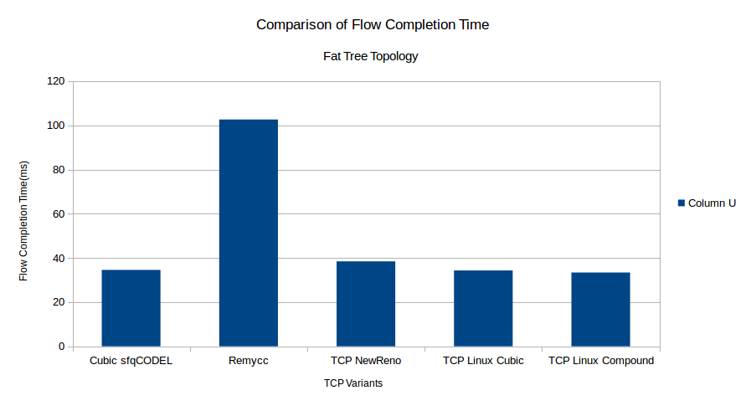
Figure 2:Average Flow Completion Time(milliseconds) across all senders comparison

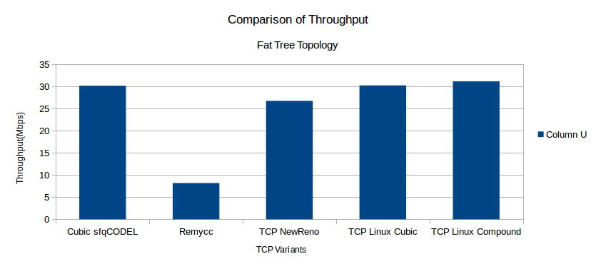
Figure 3: Average Throughput(Mbps) across all senders for the different protocols

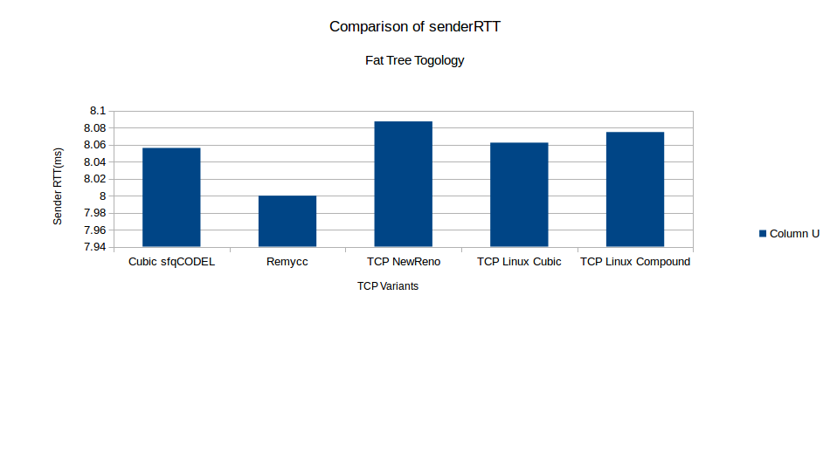
Figure 4: Average RTT(milliseconds) across all senders for the different protocols

As can be seen, the results do not favor the RemyCC as it performs considerably worse than any of the other protocols . We did not consider to make a comparison against DCTCP or pFabric as we need to first improve it against such protocols which are not catering specifically to datacenter workloads or topology which are bound to perform worse than DCTCP or pFabric in our heavy-tailed workload scenario. One of the reasons for this could be that although we had generated a RemyCC as a result of modifying the topology to a simple fat-tree one, the flow pathways used did not emulate a fat-tree topology one where each end-host is a sender and a receiver constantly generating and acknowledging traffic on it’s part.

CONCLUSION AND FUTURE WORK

After observing the results, we have concluded that it is necessary to emulate the datacenter(fat-tree) traffic pathways i.e. using end-host not just as senders but also as receivers which involves rewriting around 40-50% of the offline remy code. Another hindrance is the RAM available in laptops i.e. around 4GB, which is not enough to simulate offline Remy training phase if we provide it with more generalized parameters for example using a minimum of 8 and maximum of 32 senders and in similar ways, using a wider range of input parameters which include RTT, mean on time, mean off time, link capacity, propagation delays. This is especially important because as mentioned before, for the offline case the workloads were generated as a result of providing a minimum and maximum values for mean on time and mean off times. As it was not possible to provide the offline code with a large enough range for these parameters, the common heavy tailed distribution would not be observed in the offline phase i.e. the presumptions taken about the network are pretty narrow for it to work on datacenter workload CDFs used in the online phase in ns-2. Therefore, in the future, either the offline task could be allocated among multiple machines in a distributed manner or a better RAM size is required for it support the input configurations generated as a result of providing Remy with wider range of assumed network parameters

ACKNOWLEDGMENTS
Our thanks to our professors, Dr Ihsan Ayyub Qazi and Dr. Zafar Ayyub Qazi for guiding us every step of the way. We also would like to acknowledge the open source workloads that we used from https://github.com/HKUST-SING/PIAS-NS2.

REFERENCES
[1] Munir, Ali & A. Qazi, Ihsan & Uzmi, Zartash & Mushtaq, Aisha & N. Ismail, Saad & Safdar Iqbal, M & Khan, Basma. (2013). Minimizing flow completion times in data centers. Proceedings - IEEE INFOCOM.
[2] Mohammad Alizadeh, Shuang Yang, Milad Sharif, Sachin Katti, Nick McKeown, Balaji Prabhakar, and Scott Shenker. 2013. pFabric: minimal near-optimal datacenter transport. SIGCOMM Comput. Commun.
[3] Keith Winstein and Hari Balakrishnan. 2013. TCP ex machina: computer-generated congestion control. In Proceedings of the ACM SIGCOMM 2013 conference on SIGCOMM (SIGCOMM '13).
[4] Arjun Roy, Hongyi Zeng, Jasmeet Bagga, George Porter, and Alex C. Snoeren. 2015. Inside the Social Network's (Datacenter) Network. SIGCOMM Comput. Commun.
[5] Theophilus Benson, Aditya Akella, and David A. Maltz. 2010. Network traffic characteristics of data centers in the wild. In Proceedings of the 10th ACM SIGCOMM conference on Internet measurement (IMC '10).

Columns on Last Page Should Be Made As Close As Possible to Equal Length

